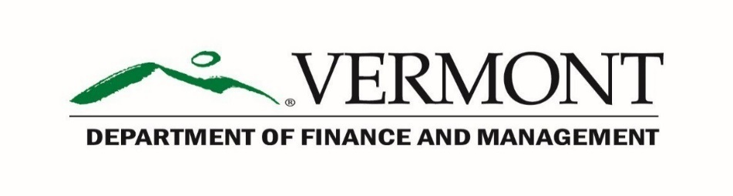

Statewide Reporting - Internal Control Unit

SAIC DVR – Corrective Action Plan (CAP) Form

This Corrective Action Plan (CAP) form covers material weaknesses, investigation assigned to, corrective action to be taken, and many other deficiencies that are discovered and identified during our annual Self-Assessment of Internal Control (SAIC) Data Validation Review (DVR) Project.
As the DVR audit results are discussed, if a “Failed” decision is received on the SAIC DVR report, the State Agency should list the identified agency & material weaknesses in column “A” on form FM SAIC_DVR - CAP Report. The Internal Control Unit and the Agency’s CFO or Senior Financial Director IV (SFD IV) shall agree on a tentative time frame for the Agency’s response and corrective action plan.
The Agency’s CFO or SFD IV should delegate the investigation of potential corrective actions, noted from the “Source of Investigation” from column “B” of the Corrective Action Plan. The Agency should ensure that the documentation is completed in writing within 10 business days from the SAIC DVR publication. The Agency should determine the appropriate corrective action(s) and a target date for completing corrective actions and list this information in columns “C” and “D” of the Corrective Action Plan form.
This corrective action plan is an open-ended plan and shall remain in effect until all deficiencies in program operations have been reduced substantially or eliminated. State agencies shall provide updates to their corrective action plans through regular, semiannual updates. These updates shall be received by the Internal Control Unit as necessary. Such updates must contain:
- Any additional deficiencies identified since the previous corrective action plan update.

- Documentation that a deficiency has been corrected and removed from the plan.

- Any changes to planned corrective actions for previously reported deficiencies.

- Specific description and identification of each deficiency.

- Magnitude of each deficiency, if appropriate, Geographic extent of the deficiency (e.g., Statewide project area or management unit - specific project areas in which the deficiency occurs).

- Identification of any action already completed to eliminate the deficiency.

- For each deficiency, a description of the manner in which the State agency will monitor and evaluate the effectiveness of the corrective action in eliminating the deficiency.

State agencies shall be held accountable for their IC’s efficiency and effectiveness of their operations. Please call F&M Statewide - Internal Control Unit @ 802.828.0672 if there are any questions.

FM SAIC DVR – CAP Form, Edition 1 Effective 10/2019
( A )  Agency / Material  Weakness | ( B )  Source of  Investigation | ( C )  Corrective Action to be  taken to resolve Weakness | ( D )  Target Date to Complete CAP
 | SAIC DVR  Question ____ |  | M D YR  ___ /___ /___
 | SAIC DVR  Question ____ |  | M D YR  ___ /___ /___
 | SAIC DVR  Question ____ |  | M D YR  ___ /___ /___
 | SAIC DVR  Question ____ |  | M D YR  ___ /___ /___

Return form to F & M – Internal Control Unit within 10 days of receipt of your Final SAIC DVR Report.
Email to Jeffrey.Montgomery@vermont.gov

