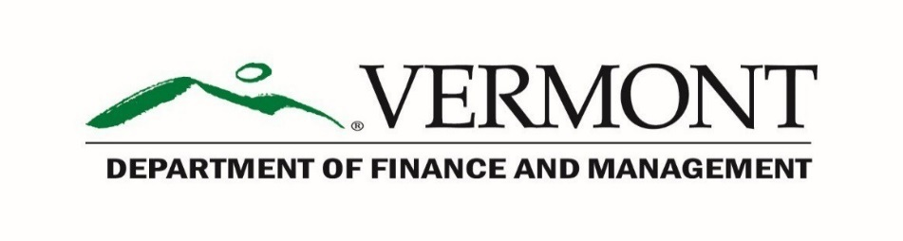
Internal Control Unit

SAIC - Internal Corrective Action Plan (ICAP) Form v 2.4
Effective Date: SAIC 2023
- The Appointing Authority is responsible for Certifying that the Internal Control Corrective Action Plan (ICAP) has been reviewed by the Appointing Authority and the Senior Financial Management of the agency and everyone agreed to the proposed Corrective Action Plan.
_____________________________________________________________________
Printed Name & Title of Top Appointing Authority – Please Date Document

For this ICAP Certification, Top Appointing Authority refers to elected officials, agency secretaries or department commissioners, heads of branches, divisions, boards, and commissions not reporting to a department commissioner or agency secretary; this certification responsibility cannot be delegated to Deputies or any other agency personnel.

- Electronic Certification Option for Appointing Authority

By accepting this box with a prelabeled X mark, I authorize the Department of Finance & Management (DFM) to accept this document transmitted from my state email account as our official ICAP submission. In addition, I certify that my name as typed above shall be treated as my written signature for the purposes of certifying this document. Important: Email submissions from the Appointing Authority's “delegate” (i.e., On Behalf of) or others are NOT permitted.
X
This Internal Corrective Action Plan (ICAP) form covers material weaknesses, investigation assigned to, corrective action to be taken, and many other deficiencies that are discovered and identified during the annual Self-Assessment of Internal Control (SAIC) - Data Validation Review (DVR) Audit.
As the DVR audit results are discussed, if a “Failed” Scoring decision is received on the SAIC DVR report, the State Agency should list the identified Agency & material weaknesses on the form. The Agency shall assign a tentative time frame for the Agency’s Target completion of the corrective action plan.
The Agency should delegate the investigation of potential corrective actions, noted from the “Source of Investigation” of the Internal Corrective Action Plan (ICAP). The Agency should ensure that the documentation is completed in writing. The Agency should determine the appropriate corrective action(s) and a target date for completing corrective action plan (s).
These updates shall be received by the Internal Control Unit and must contain:
- Any additional deficiencies identified since the previous corrective action plan.
- Documentation that a deficiency has been corrected and removed from the plan.
- Any changes to planned corrective actions for previously reported deficiencies.
- Specific description and identification of each deficiency.
- Magnitude of each deficiency, if appropriate, Geographic extent of the deficiency (e.g., Statewide project area or management unit - specific project areas in which the deficiency occurred).
- Identification of any action already completed to eliminate the deficiency.
- For each deficiency, a description of the way the State agency will monitor and evaluate the effectiveness of the corrective action in eliminating the deficiency.

Agencies shall be held accountable for their efficiency and effectiveness of their operations. Please email the ICAP Form to the DFM Internal Control Unit at jeffrey.montgomery@vermont.gov or if there are any questions.
DFM SAIC ICAP Form, v 2.4
Agency & Material (s) Weakness: | Source of Investigation:  Source is SAIC DVR Audit Review, unless otherwise stated. | Corrective Action (s) to be taken to resolve weakness: | Target date to implement ICAP resolution:

---- DFM EXAMPLE INPUT DATA ----
DFM SAIC 202x Question # 10 – Employee Separation Listing | Credible evidence to validate a YES response for the question or control being tested was not fully presented so the question failed. SAIC was answered as "Yes" but limited documentation evident from the DVR Review Audit. | We’ve attached our plan of action for future Internal Control SAIC Compliance. | Estimated ICAP correction will be in place by Year-End of 202x.

Agency’s Response to Identified Deficiencies

Please use additional sheets if necessary

